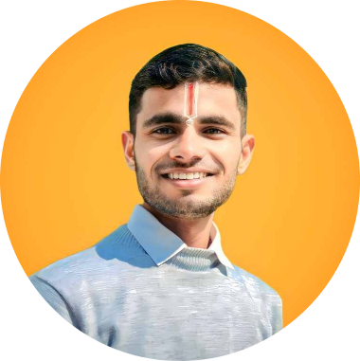 Ayush Gupta



**Profile**

I am a **Web Developer** with in **[Frontend]** development, proficient in **[Key Technologies: HTML, CSS, JavaScript]**. Passionate about building responsive, user-friendly websites and applications. Skilled in problem-solving, performance optimization, and modern web frameworks. Adept at collaborating with teams to deliver high-quality digital solutions.

**Contact**

*PHONE:*

+91-9310156028

+91-9310156028

*EMAIL:*

[ayushgupta15114gmail.com](mailto:yashikabajaj013@gmail.com)

**TRAITS**

Confident

High Grasping Power

Team Player

Excellent presentation skills

Good Convincing skills

# EDUCATION

* **Chaudhary Charan Singh University** (2022-2025)

Pursuing **Bachelor of Computer Applications** from **Global Institute Of Information Technology**, With 67% till 4th sem. [Period: 3 year]

## Schooling :Rao Kasal Public School

* XII - 59% (2020-2021)

# WORK EXPERIENCE

* **Fresh’s**

**PROJECT’S**

* Created a clone Project of **MYNTRA** with the help of **HTML , CSS** and **JAVA SCRIPT.**
* Just made a minor project on **Airlines** with the help of **Java**
* Right now I am making my own transport website **Gupta Tours and Travels.** Using **HTML, CSS** and **JS**.
* Moving Car **Animation** Using **HTML, CSS** & **JavaScript**

# HANDS IN TRAINING

* Microsoft Excel.
* MS Word
* MS PowerPoint

**TECHNICAL SKILLS SET**

* **Programming Languages: C, C++, DATA STRUCTURE , JAVA.**
* **Web designing Languages: HTML , CSS, JAVA SCRIPT.**

**Leisure Activities**

* Photo & Video Editing .
* Playing Cricket & kabaddi.
* Listing Songs.

## PERSONAL PROFILE

## Father Name - Mr. Prem Chandra Gupta

## Date of Birth - 25/02/2004

## Gender - Male

## Nationality - Indian

## Marital Status - Unmarried

## Religion - Hindu

## Language Know - Hindi , English

# CONFERENCES ATTENDED

* Participated as Speaker in 5th **INTERNATIONAL CONFERENCE MEETING on Science & Engineering of Materials (ICSEM-2025)**, **Global Institute Of Information Technology**,Gr. Noida. (4TH – 7TH January ,2025).

## Attend Trinity Institute of Innovations In Professional Studies(TIIPS), Impact of AI , Machine Learning and Big Data in the Financial Ecosystem “ on 28th February 2025, Greater Noida.

* Participated as Speaker in **IDEATHON - India Expo Centre & Mart**

**(2024) , Meerut Institute of Engineering Technology ,Meerut.**

* Participated as Speaker in **INTERNATIONAL CONFERENCE MEETING on Recent Development in the Architecture of Smart Cities using Internet of Things (ICM-2023)**, **Global Institute Of Information Technology**, Gr. Noida. (29th -30th October, 2023).
* Participated as **volunteer** in **INTERNATIONAL CONFERENCE MEETING on Recent Development in the Architecture of Smart Cities using Internet of Things (ICM-2023)**, **Global Institute Of Information And Technology**,Gr. Noida. (29th -30th October, 2023).
* Participated as Speaker in **IDEATHON - INSTITUTE’S INNOVATION COUNCIL (2024) ,International Institute of Management and Technical (iimt) GR. NOIDA.**

# WORKSHOP

## A Three-day workshop from 17-19, October 2024, on 'Life Skills and Career Development' as part of its Student Development Program (SDP), Global Institute Of Information Technology, Gr. Noida

Declaration I do hereby declare that all the above statement & details are true, Complete and correct to the best of my knowledge and belief.

Date:-

Place (Ayush Gupta)